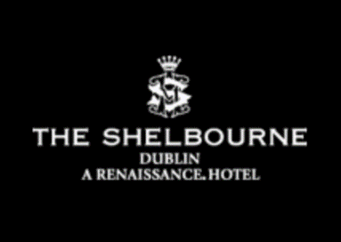
CONTACT: The Shelbourne Dublin, A Renaissance Hotel
27 St Stephen's Green, Dublin 2 Ireland
+353 1 663 4500
https://www.marriott.com/hotels/travel/dubbr-the-shelbourne-dublin-a-renaissance-hotel/

Lord Mayor’s Lounge at The Shelbourne Unveils Elegant Refurbishment
Dublin lounge reopens with a redesign and Modern Classic Afternoon Tea menu

Dublin, Ireland – May 16, 2018 – The Lord Mayor’s Lounge at The Shelbourne opens after a refurbishment led by internationally renowned designer Guy Oliver, principal designer and owner of Oliver Laws. To celebrate the reopening of the Lord Mayor’s Lounge, the new Modern Classic Afternoon Tea at the 5-star city centre hotel in Dublin focuses on old favourites from childhood memories, given a contemporary gloss.
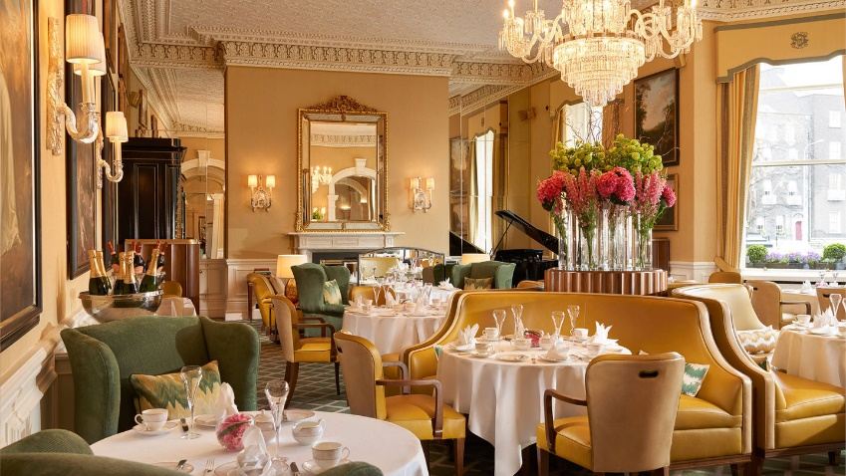
The lounge is decorated in fresh, pretty shades of golden yellow, pale green, cream and ivory, with new seating arrangements including a centrepiece banquette, similar in style to those found in many grand 19th-century hotel salons. The new redesign is a very clear tribute to its illustrious past, but with a modern sense of comfort and glamour.
Dining at the legendary Lord Mayor's Lounge
The newly refurbished lounge also reinstates a historic 19th century Waterford Crystal chandelier, an original of the hotel townhouses, and introduces a pair of handsome Chinoiserie cabinets as pantry units. Along with the piano, gilded mirrors and the classic Irish country house colour scheme of buttery yellows and golds, these touches give the sensation of being somewhere truly special. Now open, the Lord Mayor’s Lounge at The Shelbourne is home to one of the most pleasurable of rituals at Dublin’s favourite five-star hotel – afternoon tea.

Alongside the essential elements of a traditional afternoon tea – the selection of impeccably dainty sandwiches and homemade buttermilk scones with clotted cream and jams – the afternoon tea menu at The Shelbourne showcases the art of the pâtissier. The menu always includes new exceptional and exquisite pastries created by Executive Chef Garry Hughes and his talented team of pastry chefs at the luxury hotel in Dublin.

The new Classic Afternoon Tea revisits the classics while adding a little something special. Eclairs come with a surprise filling of praline flavours, a classic vanilla cheesecake has an unexpected center of zingy lime and strawberry and the panna cotta offers a fashionably current flavour combination of elderflower and rhubarb. All of these firm favourites from the past serve as both a trip down memory lane and an indulgent modern delight.

The Classic Afternoon Tea is available for €49 per person, with Champagne Afternoon Tea from €64 per person. The hotel offers three afternoon tea sittings per day, Monday to Friday, and four on Saturdays, Sundays and Bank Holidays.

For more information or to make a reservation call + 353 1 6634500 or visit shelbournedining.ie.

About the Shelbourne Dublin, A Renaissance Hotel

The Shelbourne Dublin, A Renaissance Hotel is housed in a 194-year-old historic building in the heart of the city and sets the stage for an exceptional visit to Dublin. Guest rooms and suites feature complimentary high-speed Wi-Fi, a deluxe pillowtop mattress, 24-hour in-room dining, a flat-screen TV and an elegant marble bathroom. The hotel boasts a leisure club with a fitness center and indoor pool, a tranquil signature spa and salon and true 5-star restaurant dining at The Saddle Room and Lord Mayor’s Lounge. If hosting a meeting or event, make use of the impeccably appointed, light-filled venue space and state-of-the-art planning and catering services. Let luxury surround you at The Shelbourne Dublin, A Renaissance Hotel.

# # #

