VIA Motors International, Inc. and
Zhejiang Geely New Energy Commercial Vehicle Co., Ltd. announce
Joint Venture Collaboration Agreement

- Joint Venture will launch a line of green logistics commercial vehicles for sale and distribution in North and Latin America.
- VIA Motors will co-develop a green logistics medium duty truck for Geely New Energy Commercial Vehicles (“ GCV”) in China under an exclusive arrangement which includes a technology transfer of VIA software and control systems.
- As part of this arrangement VIA will be responsible for manufacturing, sales and distribution in North and Latin America.

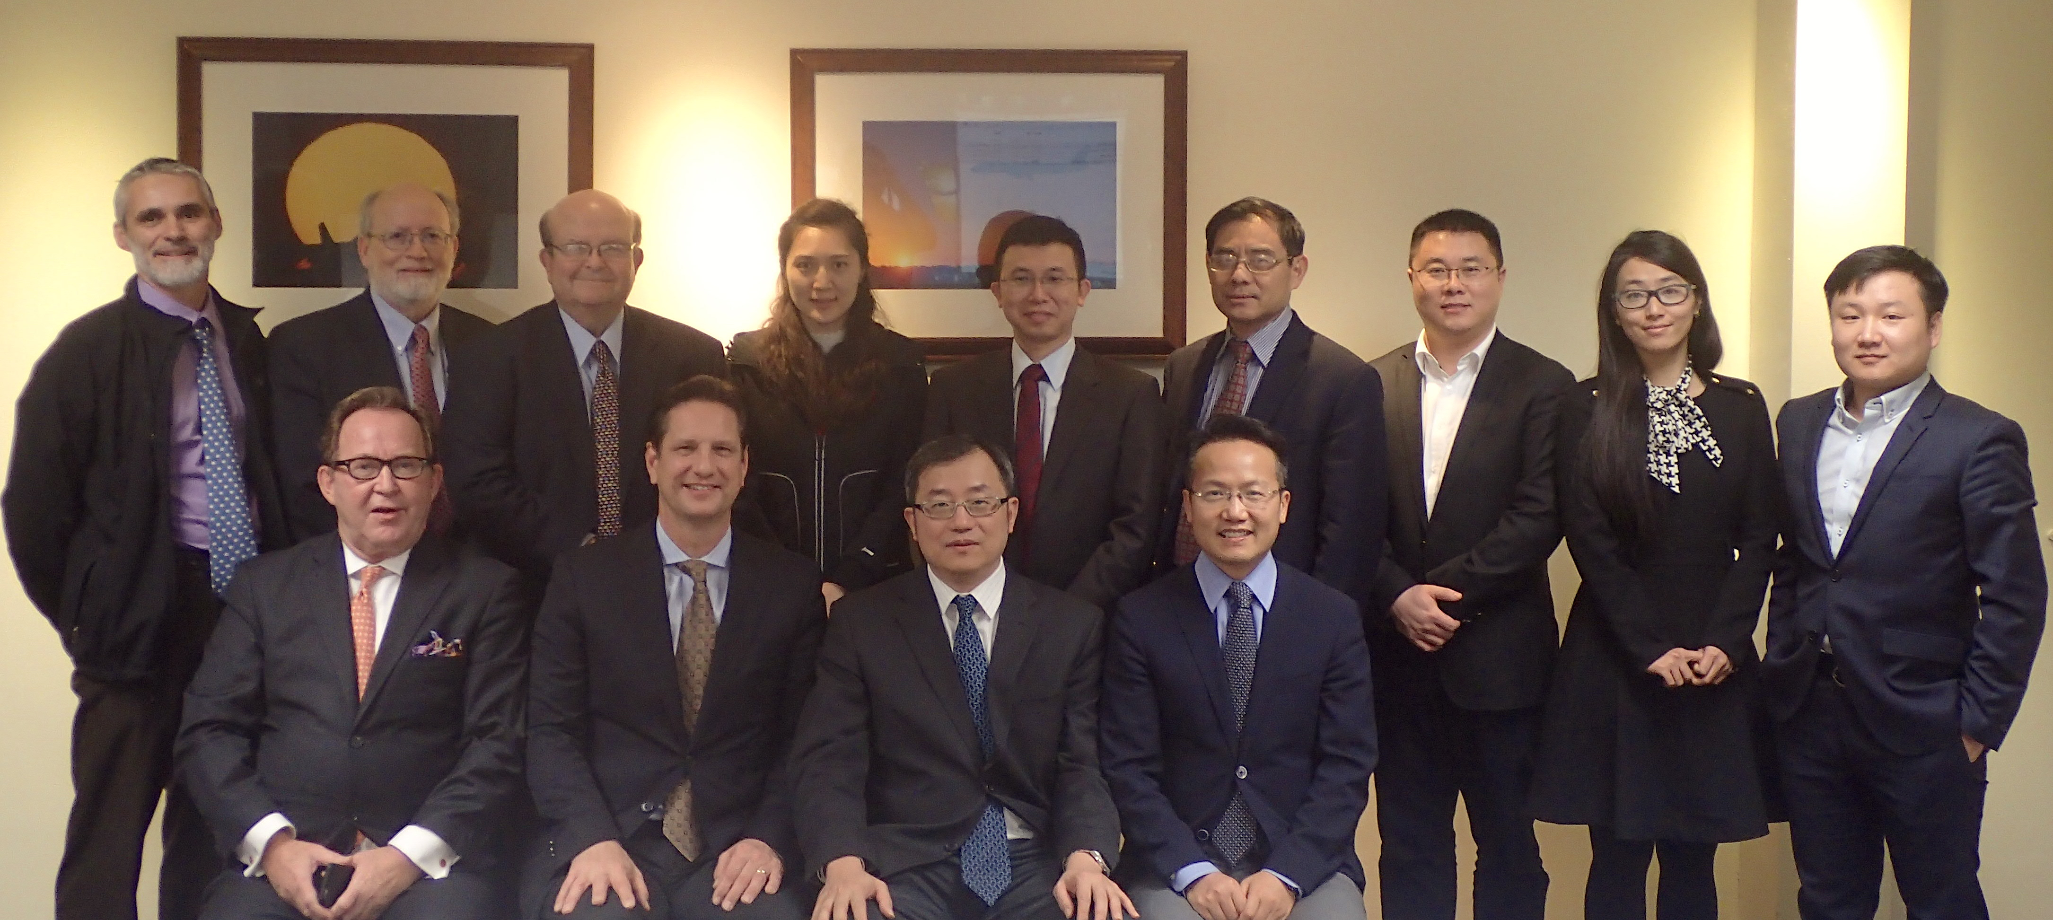
Front row: Gerald Page, Director Asia VIA. Peter Guile, CEO VIA, Nathan Yu, President Executive Advisor/VP ZGH, Chen Yiming, Int’l Legal SrDir ZGH.
Back row: Thierry Cassuat, CTO VIA. Dick Clayton, Exec VP VIA. Bob Purcell, COO VIA. Fiona Fei, Snr Manager of Chairman Office ZGH. Li Hongyan VP of GCV Research Institute. Austin Hu, VP of GCV Research Institute. Song Guanghui, Dean Ass’t GCV Research Institute. Xi Na, Int’l Legal Supervisor ZGH. Steven Song, Int’l Business Sr Manager ZGH.

Orem, Utah –January 22, 2018 In line with Geely’s corporate global vision of producing the safest, most environmentally-friendly and most energy-efficient “New Energy Commercial Vehicles,” VIA Motors International, Inc., a leader of electric and hybrid drive systems offering a range of extended range (eREV) and EV commercial vehicles, today announces that it has completed an exclusive agreement with China based Zhejiang Geely New Energy Vehicle Co. Ltd., a subsidiary of Zhejiang Geely Commercial Vehicle Group.
The parties have agreed to co-develop a medium duty extended range electric truck, which incorporates VIA’s industry leading proprietary vehicle software and systems control technology, for launch in China and the Americas in 2019.

Mr. Nathan Yu Ning, Zhejiang Geely Holding Vice President of International Business and Executive Advisor to the Board said “Geely selected VIA Motors due to the company’s advanced commercial vehicle software and control systems technology, specifically developed to meet the demanding duty cycle and performance requirements of commercial vehicles”.

“I believe that range extended hybrid drive systems are a leading technology for the next 5-10 years and the co-developed truck will utilize proven technology such as a Volvo engine for the range extender. VIA Motors provides technology plus an engineering and management team that can support GCV to accelerate to be global leading commercial vehicle company and assist the introduction of GCV Trucks into North and Latin America through our newly formed joint venture,” continued Mr. Yu.

“VIA Motors is honored to partner with Geely Commercial Vehicles. This agreement allows VIA to execute our strategy with the launch of an expanded portfolio of advanced drive systems and vehicles,” commented Peter Guile, CEO of VIA Motors. “We are excited to be working with our new global partners to electrify the future of the world’s working vehicles,” he continued.

“Geely is the ideal strategic partner for VIA Motors, as the fastest growing global vehicle company, with a demonstrated commitment to the electrification of their portfolio of award winning vehicles.” commented Bob Lutz, Chairman of VIA Motors and former Vice-Chairman of GM. “The alliance between Geely and VIA Motors combines technology, access to their industry leading suppliers, and a mutual entrepreneurial spirit dedicated to accelerating the global adoption of extended range electric commercial vehicles.” further commented Mr.Lutz.

ABOUT VIA MOTORS

VIA Motors International, Inc. develops and markets extended-range electric (eREV) and all electric (EV) power-train systems, incorporating industry leading VIA developed vehicle software and control systems technology, which provides clean energy solutions for most vehicle classes from light duty through Class 8.

VIA’s vehicle integration capability, at both production facilities in Utah and Mexico, provides a range of commercial vehicles to meet zero emissions requirements. VIA vehicles are marketed under the VTRUX^{tm} brand and under the VIA power-train systems V-Drive^{tm} brand.

ABOUT GEELY COMMECIAL VEHICLE GROUP

Zhejiang Geely Commercial Vehicle (GCV) is a subsidiary of Zhejiang Geely Holding Group (ZGH),
ZGH consists of many well-known international automotive brands including Geely Auto, Lynk & Co, Volvo Cars, Polestar, PROTON, Lotus, London Electric Vehicle Company, Yuan Cheng Auto, and Terrafugia with global operations spanning the automotive value chain, from research, development and design to production, sales and servicing. ZGH also recently announced acquisition of 8.2% of Volvo AB.

Zhejiang Geely Commercial Vehicle (GCV) has two sub brands; the London Electric Vehicle Company and Yuan Cheng Auto. The London Taxi Company (LTC) became known as the London Electric Vehicle Company (“LEVC”) in July 2017 as the company transitions into being a provider of urban focused new energy commercial vehicles. Yuan Cheng Auto has three core product lines; new energy focused trucks and bus chassis and also new energy powertrains. Yuan Cheng launched its first core products in October 2016 with the introduction of the E12 pure electric city bus and an E200 pure electric logistics vehicle.

GCV has two core research and development centers in Hangzhou, China and Coventry, UK with over 2,000 engineers and production facilities in both China and the UK together with a total of over 3,000 production and administration staff.

FORWARD LOOKING STATEMENTS

We cannot be certain that any expectation, forecast, or assumption made in preparing forward looking statements will prove accurate, or that any projection will be realized. It is to be expected that there may be differences between projected and actual results. Our forward looking statements speak only as of the date of their initial issuance, and we do not undertake any obligation to update or revise publicly any forward looking statement, whether as a result of new information, future events, or otherwise.

For further questions please contact:

North America: Asia:
Peter Guile Gerald Page
CEO Executive Director China
peter.guile@viamotors.com gerald.page@viamotors.com

General Contact Info:
VIA Motors International Inc.
165 Mountain Way Drive
Orem, UT 84058
USA
801 764 9111
info@viamotors.com

